Media Contact:
Eric Skelly, 713-665-2700, eric@rocohouston.org

ROCO Begins Second Decade With “Side By Side”
11th Season Celebrates Partnerships

FOR IMMEDIATE RELEASE: July 31, 2015

HOUSTON ― ROCO (River Oaks Chamber Orchestra) launches its second decade with the 2015-2016 season, its 11th, titled “Side By Side.” Eleven new world premiere commissions bring ROCO’s world premiere total to 54 by the end of this season, characterized by programming that celebrates the artistic partnerships and creative collaborations that have brought ROCO through its first ten years, while exploring exciting new connections -- including moving two series into Houston’s newest performing arts center, The MATCH (Midtown Arts and Theater Center Houston) -- and intriguing musical juxtapositions. And finally, Side By Side references all of the many communities that combine to make up Houston, and which ROCO remains committed to reaching out to through performances. Although River Oaks is part of ROCO’s name, only four of ROCO’s 39 concerts last season took place there, with this season marking ROCO’s first forays as far North as The Woodlands.
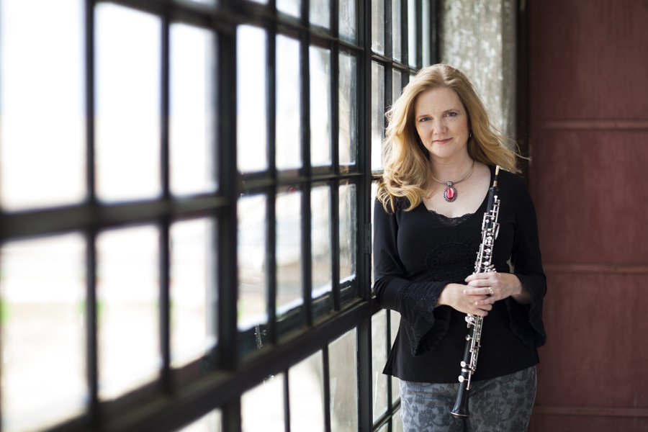
“The concept of ‘Side By Side’ starts simply with two 1’s standing together to create the number 11 as ROCO embarks on its 11th season,” explains ROCO Founder, Artistic Director and Principal Oboist Alecia Lawyer. “But ‘Side By Side’ also describes a season in which we’re thanking and spotlighting the partners - new and established - who stand beside us, as we endeavor through music to unite the disparate corners of this wonderfully diverse, sprawling city of ours. And finally, ‘Side By Side’ points to our 11th Season’s programming theme, wherein East meets West, historical meets modern, and longstanding artistic friendships are brought to the fore and celebrated.”

World premiere commissions for ROCO this season include Rick Robinson’s “Gitcha Groove On!” (commission sponsored by The Wortham Foundation), “The Age of Air” James Matheson for orchestra and two shakuhachi (commission sponsored by The Albert and Ethel Herzstein Foundation and The Wortham Foundation), Marcus Maroney’s Concerto for Orchestra (commission sponsored by The Wortham Foundation), and Dorothy Gates’ Trombone Concerto (commission sponsored by The Wortham Foundation).

Guest artists making their ROCO debuts this season include composers Rick Robinson, James Matheson, and Dorothy Gates; Shakuhachi (traditional Japanese flutes) soloists James Nyoraku Schlefer and Akihito Obama; concertmaster/soloist Scott St. John; and ROCO principal trombonist Thomas Hulten making his ROCO solo debut.

Returning ROCO guest artists include composers Reena Esmail, Marcus Maroney, and Anthony DiLorenzo; and conductors, Andrés Cárdenes, Edwin Outwater, and Victor Yampolsky.

IN CONCERT – Full Forty-Piece Chamber Orchestra
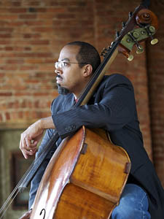
Rick Robinson
Conductor Andrés Cárdenes returns to open ROCO’s In Concert series – featuring the full 40-piece River Oaks Chamber Orchestra -- with performances of a program titled “Gitcha Groove On!,” September 26th, 2015 at St. John the Divine, and September 27th, 2015 at Miller Outdoor Theater. Pairing disparate musical styles like jazz and classical, “Gitcha Groove On!” takes its name from ROCO’s 44th world premiere commission of the same name by Rick Robinson (in his ROCO debut). It’s a jazz-infused classical commission for the full orchestra plus trapset, the product of ROCO winning the New Music Box and ASCAP “Music Alive” Partnership award. Cardénes has chosen to pair this piece with José Pablo Moncayo’s “Huapango,” a chamber orchestra piece based on folk songs from the composer’s native Mexico, and both Robinson and Moncayo have written pieces rooted in their respective heritages. Poulenc’s “Sinfonietta” and Erich Wolfgang Korngold’s “Much Ado About Nothing” complete the program.

East meets West as “Pacific Crossings” celebrates ROCO’s partnership with Asia Society Houston, November 14th at St. John the Divine. Conductor Edwin Outwater leads the ensemble the commissioned world premiere “The Age of Air” by James Matheson (making his ROCO debut) for orchestra and two shakuhachi – an early Japanese end-blown flute often used in Zen meditation as well as classical , jazz, and traditional Japanese folk music – played by ROCO debuting artists James Nyoraku Schlefer and Akihito Obama. Vivian Fung’s “Pizzicato” and Sibelius 3rd Symphony round out the program. November 13th at Asia Society Houston’s Brown Foundation Performing Arts Theater, Schlefer and Obama perform a dual shakuhachi recital in conjunction with this concert.

“Matchmaking” finds ROCO’s annual conductor-less concert featuring works in which the orchestra is subdivided. Concertmaster and violin soloist Scott St. John leads the ensemble in the commissioned world premiere of Marcus Maroney’s Concerto for Orchestra, composed in the style of Bartok’s Concerto for Orchestra which divides the orchestra into pairs, as well as Haydn’s Symphony No. 6, characterized by multiple duets within the larger piece. The program is completed by Vaughn Williams’ “Lark Ascending” featuring Scott St. John, and Bartok’s “Rumanian Folk Dances,” February 13 at 5 p.m. at St. John the Divine. “Matchmaking” is further distinguished by the fact that it accomplishes the “St. John Trifecta:” it’s hosted by St. John Flynn, features Scott St. John, and takes place at St. John the Divine.

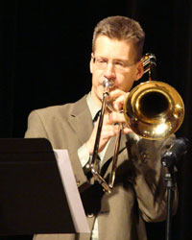
“Sliding Into Home” brings the 2015-2016 In Concert series to a close with a single performance at ROCO’s home base, St. John the Divine April 9, featuring the commissioned world premiere of Dorothy Gates’ Trombone Concerto. Principal trombonist and ROCO Brass Quintet member Thomas Hulten makes his debut as a ROCO soloist in this piece by Dorothy Gates (herself making her ROCO debut with this work), who is known among other accolades for her compositions for The Salvation Army Band. Conductor Victor Yampolsky leads the concert, which includes Vivaldi’s “Dresden” Concerto RV 577, and Arthur Honegger’s 4th Symphony, bringing ROCO’s 11th In Concert Series sliding into home.
Thomas Hulten

ROCO’s In Concert performances this season feature a very special ROCO commission. ROCO trumpets perform fanfares after each concert’s “Take Five” intermission, to call the musicians back to the stage. This season that fanfare is a commissioned piece by Anthony DiLorenzo called “Side By Side” in honor of ROCO Founder Alecia Lawyer’s father, referencing the old standard song the Lawyer family would sing in the car on family road trips.

UNCHAMBERED – Intimate Chamber Ensemble Series Featuring Individual ROCO Musicians

ROCO’s Unchambered Series has a new home this season at The MATCH (Midtown Arts and Theater Center Houston). “Houston has an exciting, versatile new performing arts center opening this Fall,” says ROCO Associate Artistic Director and Violist Suzanne LeFevre. “The MATCH is perfect for ROCO; its theaters are scaled for intimate performance experiences and have the potential for more creative collaborations with other resident organizations. The Unchambered Series now has a home. It’s a perfect MATCH!”

The series opens October 18, 2015 with “Harmonious Muses.” Violinist Anton Miller performs works by composers who inspired one another in their own time, and across generations. Gershwin’s “It Ain’t Necessarily So” is performed alongside “Park Slope” by Errollyn Wallen, a composer who’s a personal friend of Anton Miller’s, and who was greatly influenced by Gershwin (both are songwriters of popular music, as well as classical music and opera). Miller also performs works by two 19th-Century composers who inspired one another personally and professionally: Brahms’ D-minor Sonata, and Clara Schumann’s “3 Romances for violin and piano.

Pianist Christopher McKiggan takes The MATCH stage with not one, but two pianos! “Piano vs. Piano” offers a side-by-side comparison of an 1863 Steinway vs. a modern one, with McKiggan performing works on the 1863 instrument from the time of its creation, including Balakierev’s “Mazurka No. 2,” Liszt’s “Les Adieux,” Tchaikovsky’s “The Seasons,” Brahms-Paganini’s “Variations Book 2,” and ending with Karim Al-Zand’s “Paganini Reverie.” Works performed on the new instrument include Robert Beaser’s “Pag-Rag,” Narong Prangcharoen’s “Pact Ink,” and James Mobberley’s “Capricious Invariance.” The “Piano vs. Piano” showdown takes place February 28, 2016.

“Dressed To The Nines” features ROCO’s players performing Josef Rheinberger’s Nonet in A-major, considered the one of the best of the few nonets in the classical canon. The April 24, 2016 program is filled out with works that split up the nonet into a woodwind quintet for Ligeti’s “Bagatelles,” and a trio for Dohnanyi’s “Serenade” for violin, viola and cello.

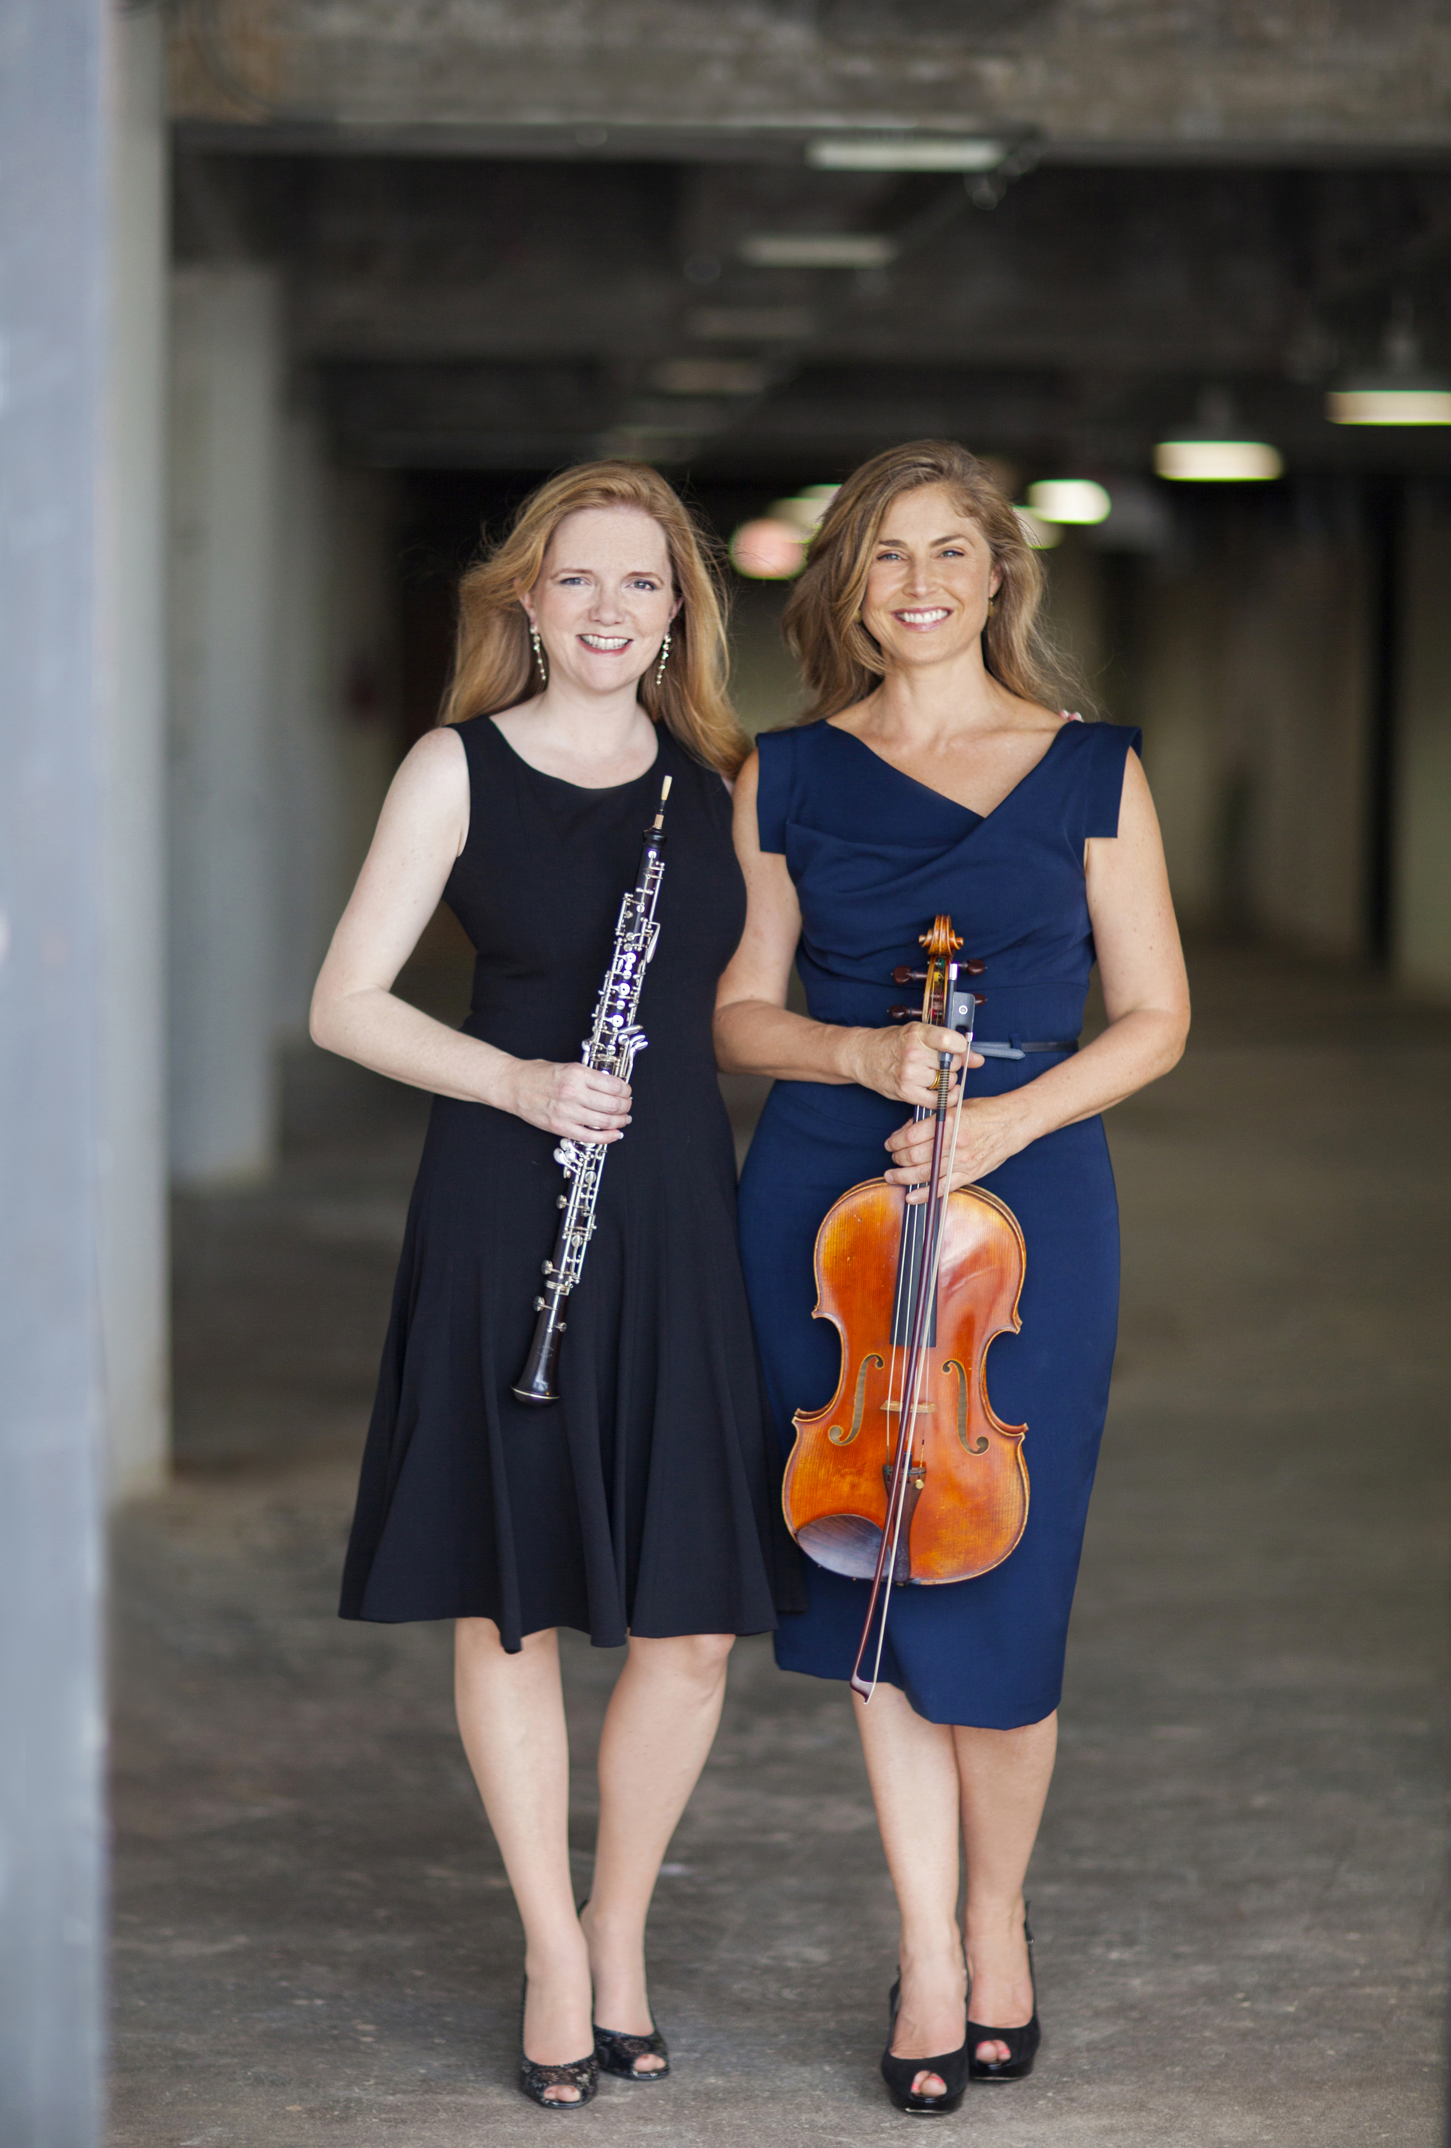
The Unchambered Series and ROCO’s 2015-2016 season closes May 15, 2016 with a very special concert titled “As Long As We’re Together.” It features ROCO Founder/Artistic Director/Principal Oboist Alecia Lawyer and ROCO Associate Artistic Director/Violist Suzanne LeFevre. They’re performing works by Hugo Kauder and Ignaz Lachner, Robert Kahn’s “Serenade,” and more. The performance is crowned by the performance of a world premiere piece: “I’ve commissioned composer Reena Esmail to write a piece for us in honor of Suzanne LeFevre,” explains Alecia Lawyer, “whose brilliance as an artist and as a human being is at the heart of everything ROCO does. I’m thrilled that we finally get to do this concert together.”
Alecia Lawyer and Suzanne LeFevre

BRASS QUINTET

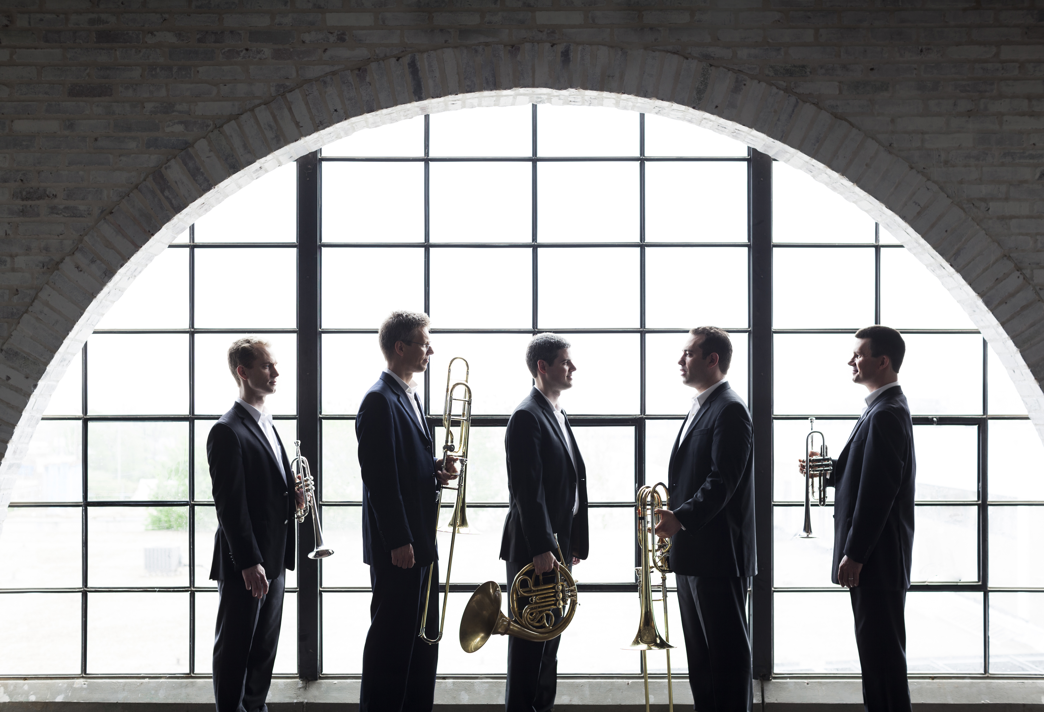
The celebrated ROCO Brass Quintet gets a 3-concert series, with repeats, of its own with performances of each concert at The MATCH and in The Woodlands. “ROCO is built on the LEGO model,” explains Alecia Lawyer, “wherein smaller groups like the ROCO Brass Quintet develop their own unique identity and their own concert series under the larger ROCO brand. This allows ROCO to reach much further and serve the entire Houston community, and strengthens the full orchestra’s artistic growth.”
ROCO Brass Quintet

The ROCO Brass Quintet comprises George Chase, trumpet; Jason Adams, trumpet; Gavin Reed, horn; Thomas Hulten, trombone; and Ilan Morganstern, bass trombone. The quintet’s first ever ROCO series programs will include performances of Robert Maggio’s “A Sense of Space,” Joan Tower’s “Copperwave,” and David Sampson’s “Morning Music.”
- October 9, 2015 at 7:30 p.m. at The MATCH; November 15, 2015 at 5 p.m. at Woodlands United Methodist Church
- January 22, 2016 at 7:30 p.m. at The MATCH; January 24, 2016 at 5 p.m. at The Woodlands United Methodist Church
- March 4, 2016 at 7:30 p.m. at The MATCH; March 6, 2016 at 5 p.m. at The Woodlands United Methodist Church

CONNECTIONS – Unique Collaborations With Dynamic Partners Throughout The Community

In addition to their own series, the ROCO Brass Quintet is once again busy in 2015-2016 headlining many of ROCO’s Connections Concerts. Fast becoming Houston traditions, ROCO’s full line-up of collaborations comprises:
- ROCO celebrates the Mexican “Day of the Dead” with its annual Musical and Literary Ofrenda at Lawndale Art Center October 27, 2015. This free five-way collaboration finds ROCO partnering with Lawndale; Musiqa; Inprint, Inc.; and the Houston Hispanic Forum; all promoted by The Mexican Consulate. The five original musical “ofrendas” (offerings) - commissioned by ROCO from Musiqa composers – are woven amongst four original prose texts by Inprint authors, surrounded by the beautiful retablos (alterpieces) on display at Lawndale.
- The Brass Quintet performs at Grace Presbyterian Church November 8, 2015, and again at The Centrum on Cypress Creek FACE’s series November 10, 2015.
- ROCO offers a very special performance of Olivier Messiaen’s “Quartet for the End of Time at The Match, November 22, 2015, featuring ROCO clarinetist Maiko Sasaki. This large and intensely moving piece was composed by Messiaen while he was held in a Nazi prisoner of war camp in 1941. The world premiere was performed by the 31-year-old Messiaen and 3 other prisoners, in the rain, on decrepit instruments, for an audience of fellow prisoners and guards. Messiaen declared that the work was inspired by of one of The Book of Revelations’ grandest, most inspiring passages.
- ROCO ushers in the holiday spirit with The 7th Annual Yuletide performances by the ROCO Brass Quintet at Bayou Bend Collection and Gardens, December 7, 2015.
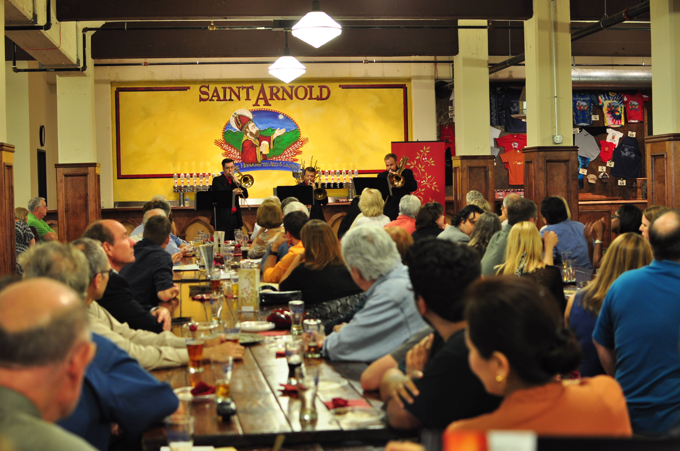
- The perennial favorite “Beer and Brass” to St. Arnold’s Brewery for a “spirited” event of craft beers and traditional beer hall music by The ROCO Brass Quintet,” January 6, 2016.
- ROCO partners with Interactive Theater Company once again to bring Prokofieff’s “Peter and the Wolf” to life at The Houston Zoo, January 17, 2016. Free with zoo admission, these performances are part of The Houston Zoo’s initiative to promote wolf conservation.
- The ROCO Brass Quintet will once again appear as part of the City West University Place Parks and Recreation Department’s “Music Under the Stars” Classical Concert Series in Colonial Park, April 22, 2016 at 7 p.m.

Subscriptions to ROCO In Concert and ROCO Unchambered or a ROCO Combo for both series are available starting Friday, April 24. Subscription prices range from $50 - $200, with discounted tickets available for Seniors and Students. Single concert tickets will become available starting August 1. Tickets and more information are available online at www.rocohouston.org or by calling 713-665-2700.
ROCOrooters

Our popular music education/childcare program for kids between 2 months (after their first set of shots) and 10 years runs during and after concerts at St. John the Divine. Kids enjoy fun music and concert etiquette instruction, a trip into the concert hall (for ages 5-10), and an option to stay for pizza and movies after the concert, allowing parents (or grandparents!) to go out for a post-concert dinner.

ABOUT ROCO

ROCO is a professional chamber orchestra of 40 all­star musicians, distinguished guest
conductors and dynamic composers who come together from all over the world to
present engaging performances of classical and original compositions. Founded in 2005
by oboist Alecia Lawyer, ROCO is the most fun you can have with serious music.
More at www.rocohouston.org

###

