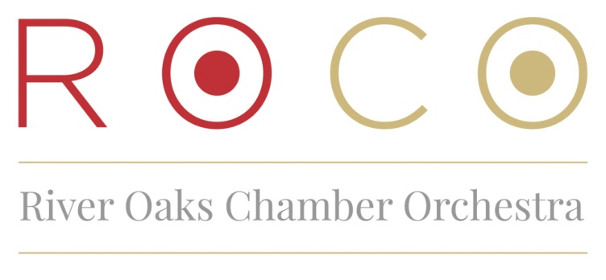

Named by Musical America as one of classical music's Top 30 Influencers for 2015, Alecia Lawyer is the Founder, Artistic Director, and Principal Oboist of ROCO, a professional music ensemble that flexes from 1 to 40 musicians from around the US and Canada, including guest conductors from around the world. The group performs dozens of concerts annually in multiple venues throughout Houston, many of which are broadcast nationally and live streamed to the world. Known as "The Most Fun You Can Have with Serious Music!” ROCO has been called a trailblazer and arts disrupter and is leading the sector in innovation.
Ms. Lawyer was named a finalist for Texas Musician of the Year (along with Willie Nelson) and was listed as one of Houston’s Top 50 Most Influential Women. She has received numerous awards, including the Gutsy Gal Award from Houston Woman Magazine, Sigma Alpha Iota Musician of the Year, and Outstanding Chamber Orchestra Founder from the Houston Chronicle. She regularly presents her entrepreneurial model and dynamic ideas to conservatories, universities, and music festivals around the US, such as Juilliard, Yale, SMU, Round Top, and the Texas Music Festival, using ROCO as a case study for community-specific orchestral building. Business and social groups in the Greater Houston Area engage her to speak on numerous topics related to the creation, innovation, marketing, and development of the arts. A member of the Houston Committee on Foreign Relations and a participant in the Aspen Leadership Seminar at the Aspen Institute, Alecia continues to weave musicians and audience together with the language of music through innovative programming and collaboration with ROCO.
After receiving her Masters from Juilliard and her Bachelors from SMU, Alecia’s career has ranged from recording for John Cage and soloing with Rostropovich, to a contemporary chamber music recital at Carnegie Hall, live radio broadcasts in New York, and disc jockeying for KRTS-92.1FM, Houston, TX. Enjoying a year residency in France, she recorded with the Sorbonne Orchestra, performed recitals in Paris, and concertized with various orchestras and chamber groups in France and Germany. Alecia and her husband Larry have two fantastic sons, Jacob, 18 and Zachary, 15.
PLEASE NOTE: If you would like to make any edits to this biography or include it in a concert program or other materials, please contact Rachel Smith, Marketing and Audience Engagement Coordinator [rachel@roco.org]

