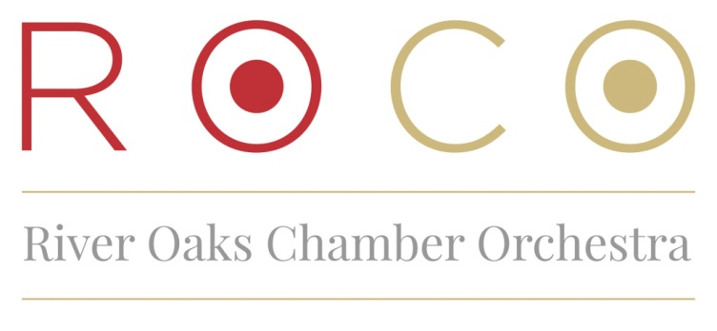

Amy Gibbs joined ROCO in March 2017 as the Managing Director; she is responsible for managing the administrative operations of the organization, including finance, human resources, marketing, and fundraising. She works closely with Artistic Director, Alecia Lawyer, and the staff to fulfill the organization’s mission to shape the future of classical music.
Previously, Amy served as the Capacity Building Manager at Houston Arts Alliance (HAA), overseeing four flagship grant programs specifically designed to provide targeted, hands-on services for small and mid-sized organizations at different life stages. She also had the opportunity to develop special opportunity programs, including the Jamail Innovation Grant and New Pathways for the Arts.
Amy also worked with AMS Planning & Research, a national arts management consulting firm, serving as an analyst and project manager on a number of planning studies for performing arts venues and market research projects. Notable clients included Pier 55 and New York Botanical Gardens in New York City; Century II Performing Arts & Convention Center in Wichita, KS; and the National YoungArts Foundation Campus in Miami.
She began her arts administration career at DataArts (formerly Cultural Data Project) where she supported a variety of organizations across the country to help them understand their financial data and utilize all the tools and services the CDP provides. Amy also worked on several internal projects to optimize performance and productivity by reviewing the uses of CDP data in the field, implementing new technology strategies, and developing new staffing structures.
Amy holds an MS in Arts Administration from Drexel University, a BA in Drama from Trinity University, and a Certificate in Nonprofit Finance through Rice University’s Center for Nonprofit Leadership and Philanthropy.
PLEASE NOTE: If you would like to make any edits to this biography or include it in a concert program or other materials, please contact Rachel Smith, Marketing and Audience Engagement Coordinator [rachel@roco.org]

